CHAPTER FOUR
DATA PRESENTATION AND ANALYSIS
  - Preamble
In this chapter, we delve into the heart of the research by carefully analyzing the collected data and presenting the findings in a clear and coherent manner. The goal of this chapter is to transform raw data into meaningful insights that address the research questions and objectives outlined earlier in the study. The presentation of results was derived from responses received from the respondents. Descriptive statistics such as percentages, frequencies, mean and standard deviation were used to summarize the demographic data and responses of the questionnaire. Regression analysis was employed to test the hypotheses while putting the null hypotheses to test.

  - Descriptive analysis of the socio-demographic data of the respondents
The socio-demographic characteristics of respondents are crucial for understanding the content of the research and to also provide insights into the diversity and representativeness of the sample.
S/N | Variables |  | (N) | (%)
 | Age | Below 20 | 52 | 19.2%
 | Age | 20–24 | 173 | 63.8%
 | Age | 25–29 | 43 | 15.9%
 | Age | 30 and above | 3 | 1.1%
 | Age | Total | 271 | 100%
 | Gender | Male | 179 | 66.1%
 | Gender | Female | 89 | 32.8%
 | Gender | Prefer not to say | 3 | 1.1%
 | Gender | Total | 271 | 100%
 | Marital status | Single | 253 | 93.4%
 | Marital status | Married | 12 | 4.4%
 | Marital status | Others | 6 | 2.2%
 | Marital status | Total | 271 | 100%
 | Faculty | Arts | 22 | 8.1%
 | Faculty | Management Science | 115 | 42.4%
 | Faculty | Engineering | 29 | 10.7%
 | Faculty | Law | 14 | 5.2%
 | Faculty | Science | 46 | 17%
 | Faculty | Others | 45 | 16.6%
 | Faculty | Total | 271 | 100
 | Level of study | 100 | 17 | 6.3%
 | Level of study | 200 | 50 | 18.5%
 | Level of study | 300 | 65 | 24%
 | Level of study | 400 | 92 | 33.9%
 | Level of study | 500 | 14 | 5.2%
 | Level of study | Post graduate | 33 | 12.2%
 | Level of study | Total | 271 | 100%

INTERPRETATION
The socio demographic details of the respondents displayed above shows the percentages and frequencies of various categories associated with the respondents. The gender distribution shows a significant advantage towards the male gender with 179 respondents as it accounts for 66.1% of the population compared to 89 females which represents 32.8% of the population. It should be noted that 3 respondents preferred not to say their gender and that is 1.1% of the population.

Regarding the age, the highest group of respondents falls within the 20 – 24 years age range, comprising 173 participants which accounts for 63.8% of the total. The next significant group is those below 20, with 52 respondents accounting for 19.2% of the total, followed by age group 25-29 with 43 respondents (15.9%), and finally 30 and above with 3 respondents (1.1%) as depicted above.

In terms of marital status, the majority of respondents are single with 253 respondents accounting for 93.4% of the total. The next is the single status with 12 respondents which accounts for 4.4% of the population while 3 respondents chose not to state their marital status.

Also, the faculty with the highest number of respondents is management science with 115 respondents (42.4%), followed by science with 46 respondents (17%), engineering comes next with 29 respondents (10.7%), followed by Arts with 22 respondents (8.1%,) and finally law with 14 respondents (5.2%) while those that chose not to state their faculty accounts for 16.6% of the total with 45 respondents.

The level of study with the highest respondents is 400 level with 92 respondents (33.9%), followed by 300 level with 65 respondents (24%), 200 level with 50 respondents (18.5%), post graduate with 33 respondents (12.2%), 100 level with 17 respondents (6.3%), and 500 level with 14 respondents (5.2%).

The detailed breakdown of the respondents’ demographic characteristics provides a comprehensive understanding of the diversity within the sample population and also ensures that the findings reflect a broad spectrum of perspectives.

  - Descriptive Analysis of Respondents to Research Instrument
Research Question 1: Demand for life insurance policies
S/N | ITEMS | SA | A | N | D | SD | Mean | S. D
1 | I have heard of life insurance products before | 71  (26.2) | 117  (43.2) | 37  (13.7) | 24  (8.9) | 22  (8.1) | 3.70 | 1.18
2 | I am interested in buying a life insurance policy in the future | 50  (18.5) | 104  (38.4) | 79  (29.2) | 27  (10) | 11  (4.1) | 3.57 | 1.03
3 | Affordability of premiums affects my willingness to demand life insurance. | 37  (13.7) | 121  (44.6) | 71  (26.2) | 25  (9.2) | 17  (6.3) | 3.50 | 1.04
4 | I believe life insurance is necessary for financial security | 53  (19.6) | 119  (43.9) | 58  (21.4) | 27  (10) | 14  (5.2) | 3.63 | 1.07

Interpretation of table data:
For question 1: “I have heard of life insurance products before”. 26.2% of the respondents strongly agree, 43.2% agree, 13.7% are neutral, 8.9% disagree while 8.1% strongly disagreed. For research question 2, “I am interested in buying a life insurance policy in the future”. 18.5% of the respondents strongly agreed, 38.4% agree, 29.2% are neutral 10% disagree while 4.1% strongly disagreed. For research question 3: “Affordability of premiums affects my willingness to demand life insurance.”. 13.7% strongly agree, 44.6% agreed, 26.2% are neutral 9.2% disagreed while 6.3% strongly disagreed. For research question 4, “I believe life insurance is necessary for financial security”, 19.6% of the respondents strongly agree, 43.9% agree, 21.4% are neutral 10% disagree while 5.2% strongly disagreed.

Research Question 2: Socio-Cultural Drivers
S/N | ITEMS | SA | A | N | D | SD | Mean | S. D
1 | My cultural beliefs influence my perception of life insurance | 9  (3.3) | 63  (23.2) | 57  (21) | 88  (32.5) | 54  (19.9) | 2.58 | 1.15
2 | My family’s opinion affects my decision to consider life insurance | 17  (6.3) | 65  (24) | 51  (18.8) | 89  (32.8) | 49  (18.1) | 2.68 | 1.20
3 | Religious teachings and leaders influence my attitude toward life insurance. | 10  (3.7) | 59  (21.8) | 66  (24.4) | 82  (30.3) | 54  (19.9) | 2.59 | 1.14
4 | Peer influence (friends/classmates) plays a role in shaping my views on life insurance. | 11  (4.1) | 61  (22.5) | 66  (24.4) | 85  (31.4) | 48  (17.7) | 2.64 | 1.13

Interpretation of table data:
For question 1: “I have heard of life insurance products before”. 3.3% of the respondents strongly agree, 23.2% agree, 21% are neutral, 32.5% disagree while 19.9% strongly disagreed. For research question 2, “I am interested in buying a life insurance policy in the future”. 6.3% of the respondents strongly agreed, 24% agree, 18.8% are neutral 32.8% disagree while 18.1% strongly disagreed. For research question 3: “Affordability of premiums affects my willingness to demand life insurance.”. 3.7% strongly agree, 21.8% agreed, 24.4% are neutral 30.3% disagreed while 19.9% strongly disagreed. For research question 4, “I believe life insurance is necessary for financial security”, 4.1% of the respondents strongly agree, 22.5% agree, 24.4% are neutral 31.4% disagree while 17.7% strongly disagreed.

Research Question 3: Cultural Context and Acceptance
S/N | ITEMS | SA | A | N | D | SD | Mean | S. D
1 | Cultural norms in my community discourage the purchase of life insurance | 9  (3.3) | 61  (22.5) | 54  (19.9) | 88  (32.5) | 59  (21.8) | 2.53 | 1.16
2 | Life insurance is perceived in my community as unnecessary or wasteful | 9  (3.3) | 60  (22.1) | 76  (28) | 78  (28.8) | 48  (17.7) | 2.65 | 1.11
3 | I believe cultural values in Nigeria significantly shape students’ acceptance of life insurance | 27  (10) | 96  (35.4) | 81  (29.9) | 46  (17) | 21  (7.7) | 3.23 | 1.09

Interpretation of table data:
For question 1: “I have heard of life insurance products before”. 3.3% of the respondents strongly agree, 22.5% agree, 19.9% are neutral, 32.5% disagree while 21.8% strongly disagreed. For research question 2, “I am interested in buying a life insurance policy in the future”. 3.3% of the respondents strongly agreed, 22.1% agree, 28% are neutral 28.8% disagree while 17.7% strongly disagreed. For research question 3: “Affordability of premiums affects my willingness to demand life insurance.”. 10% strongly agree, 35.4% agreed, 29.9% are neutral 17% disagreed while 7.7% strongly disagreed.

Research Question 4: Societal Perception and Public Awareness
S/N | ITEMS | SA | A | N | D | SD | Mean | S. D
1 | Lack of awareness campaigns limits students demand for life insurance | 60  (22.1) | 126  (46.5) | 57  (21) | 19  (7) | 9  (3.3) | 3.77 | 0.98
2 | Negative societal perception (e.g., distrust of insurers) reduces students’ interest in life insurance | 66  (24.4) | 106  (39.1) | 62  (22.9) | 31  (11.4) | 6  (2.2) | 3.72 | 1.03
3 | I believe improved public education would increase students’ demand for life insurance | 74  (27.3) | 101  (37.3) | 60  (22.1) | 28  (10.3) | 8  (3) | 3.76 | 1.06
4 | Trust in insurance companies is essential for students’ willingness to accept life insurance. | 75  (27.7) | 111  (41) | 56  (20.7) | 21  (7.7) | 8  (3) | 3.83 | 1.02

Interpretation of table data:
For question 1: “I have heard of life insurance products before”. 22.1% of the respondents strongly agree, 46.5% agree, 21% are neutral, 7% disagree while 3.3% strongly disagreed. For research question 2, “I am interested in buying a life insurance policy in the future”. 24.4% of the respondents strongly agreed, 39.1% agree, 22.9% are neutral 11.4% disagree while 2.2% strongly disagreed. For research question 3: “Affordability of premiums affects my willingness to demand life insurance.”. 27.3% strongly agree, 37.3% agreed, 22.1% are neutral 10.3% disagreed while 3% strongly disagreed. For research question 4, “I believe life insurance is necessary for financial security”, 27.7% of the respondents strongly agree, 41% agree, 20.7% are neutral 7.7% disagree while 3% strongly disagreed

  - Test of Hypotheses (Inferential Statistics)
In this section, the proposed null hypotheses were put to test. The p value must be less than the standard significant level of 0.05 for the test to result in a rejection of the null hypotheses.

    - Hypothesis One
H_{o}: There is no significant relationship between socio-cultural drivers and the demand for life insurance policy
H_{i}: There is a significant relationship between socio-cultural drivers and the demand for life insurance policy

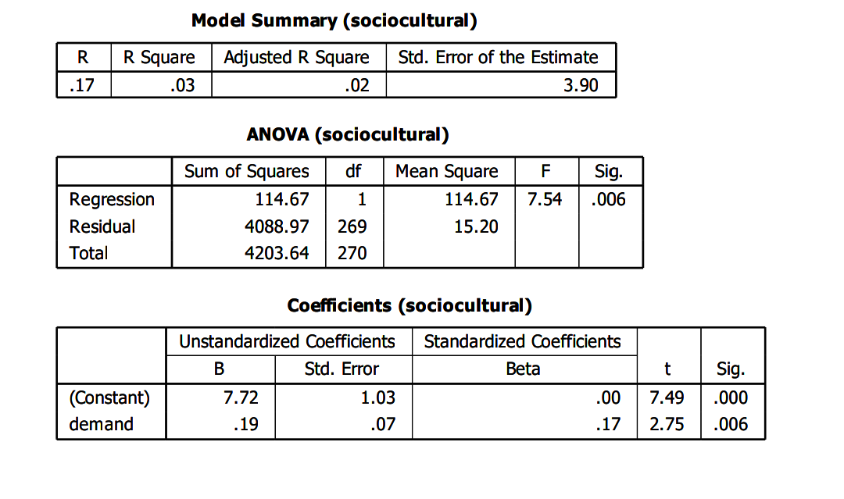
The regression analysis above confirms that the relationship between sociocultural demand and the dependent variable is statistically significant at 1% level. The predictor (sociocultural demand) is statistically significant (p = .006), which means it has a real (non-random) effect on the dependent variable. However, the effect size is weak (R² = 0.03), meaning that while the relationship exists, it explains only a small portion of the dependent variable. The result suggests that sociocultural demand (such as societal expectations, cultural values, or norms) has a positive but limited impact on the outcome. This indicates that while sociocultural factors matter, they are not the primary drivers of life insurance policy. Other variables such as economic, organizational, psychological, or structural likely explain more variance. Therefore, the regression analysis reveals that sociocultural demand has a statistically significant but weak positive effect on life insurance policy. With an R² of 0.03, the model explains only a small proportion of variance, meaning most of the outcome is driven by other factors. Thus, while sociocultural influences are important and cannot be disregarded, they should be integrated with broader strategies addressing economic, organizational, and psychological dimensions in order to achieve meaningful improvements.
    - Hypothesis Two
H_{o}: Cultural context has no significant impact on the demand for life insurance
H_{i}: Cultural context has significant impact on the demand for life insurance
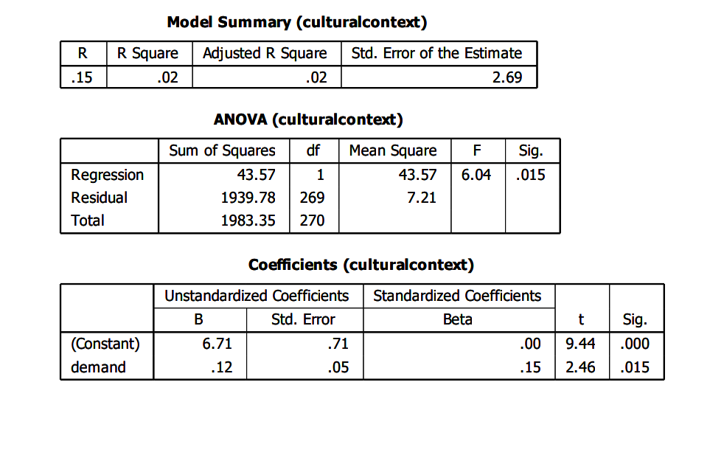
The F-value of 6.04 with a p-value of .015 indicates that the regression model is statistically significant at the 0.05 level. This means that demand contributes meaningfully to predicting cultural context, and we reject the null hypothesis. The unstandardized coefficient (B =.12) suggests that for every one-unit increase in demand, cultural context perception increases by 0.12 units. The standardized coefficient (Beta =.15) shows a modest effect size. The t-value (2.46) and p-value (.015) confirm that demand is a statistically significant predictor. The p-value (.015) for the predictor variable demand is below the conventional threshold of 0.05. The F-test confirms that the model is statistically significant. Therefore, we reject the null hypothesis and accept the alternative “cultural context has significant impact on the demand for life insurance”. This study provides empirical evidence that demand for life insurance is statistically significant, albeit weak predictor of cultural context perception. While the effect size is modest, the findings contribute to the broader understanding of how market or societal demand may shape cultural interpretations.
.
    - Hypothesis Three
H_{o}: Societal perceptions have no significant influence on the demand for life insurance products
H_{i}: Societal perceptions have significant influence on the demand for life insurance products
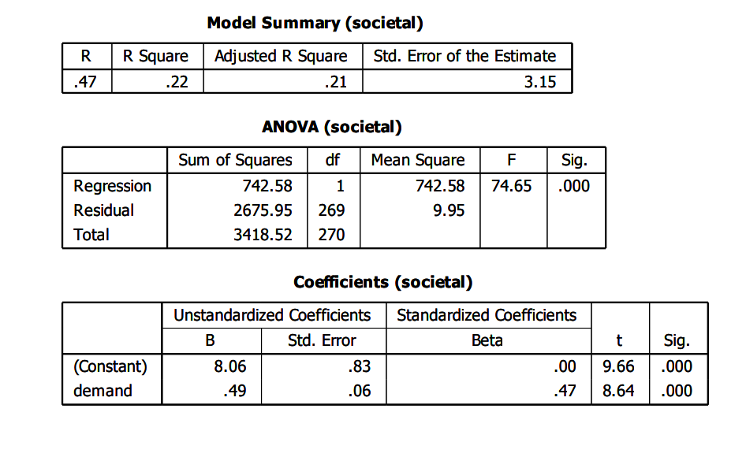
The F-statistic of 74.65 with a p-value of.000 indicates that the regression model is highly statistically significant. This means that the predictor variable (demand) contributes meaningfully to explaining societal perception, and we can confidently reject the null hypothesis. The unstandardized coefficient (B = 4.89) indicates that for every one-unit increase in demand, societal perception increases by 4.89 units. - The standardized coefficient (Beta = 0.47) reflects a moderate effect size, suggesting that demand has a meaningful impact. The t-value (8.64) and p-value (.000) confirm that demand for life insurance is a highly significant predictor. The p-value (.000) for the predictor variable demand is well below the 0.05 threshold. The F-test confirms the overall model’s significance. The Beta coefficient (.47) indicates a moderate effect size. Therefore, we reject the null hypothesis and accept the alternative “societal perceptions have significant influence on the demand for life insurance products”. The standard error (3.15) indicates some variability in prediction accuracy. This regression analysis provides robust evidence that demand is a statistically significant and moderately strong predictor of societal perception. The findings suggest that as demand for life insurance increases whether in economic, cultural, or social contexts individuals’ perceptions of societal structures or norms shift accordingly.

  - Discussions of Findings
All the null hypotheses tested were rejected as their corresponding p-values were below the significance level of 0.05. This study clarifies the ambiguity surrounding compensation in relation to employee performance. The results obtained are consistent with the majority of existing research, reinforcing the significance of life insurance policy on the dependent variables.

Hypothesis One: There is no significant relationship between socio-cultural drivers and the demand for life insurance policy
The study explores the relationship between socio-cultural drivers and demand for life insurance policy. The responses from the questionnaire support those findings with majority of participants recognizing compensation as a key factor in enhancing their performance. The strong statistical evidence from this study supports the hypothesis that there is no significant relationship between socio-cultural drivers and the demand for life insurance policy. The result of the findings indicated significant correlation between the variables. The findings indicated that peer influence on life insurance decisions are not heavily shaped by social circles. It is suggested that there is need to leverage peer groups to spread awareness, but avoid pressure tactics while focusing on open discussions and testimonials. These findings are consistent with the existing study by Adamu (2018), who used Ajzen's theory of planned behaviour (TPB) to characterize the acceptance and use of insurance services among northern Nigerians. Religious beliefs, subjective norms, and behavioural control variables were found to be ineffective in explaining poor acceptance and patronage for demand for life insurance practices. The findings highlight many demographic aspects as well as their opinions towards insurance firms and their services. The results of such a study would be a valuable information for insurers in developing marketing tactics to further stimulate and enhance patronage and perceptions of insurance services.
Hypothesis Two: Cultural context has no significant impact on the demand for life insurance The study also explores the impact of cultural context on the demand for life insurance. The analysis revealed that there is a positive relationship between cultural context and the demand for life insurance as confirmed by high statistical significance. The study found out that cultural norms may not be a dominant barrier, but they still influence a subset of the population. It is therefore suggested that campaigns that clarify the purpose and benefits of life insurance especially in communities where it is seen as unnecessary or wasteful. These findings are consistent with the existing empirical study by Kelikume and Otonne (2022) who investigated Nigeria's house and property insurance factors in the Lagos Metropolitan Area. It was found out that culture, religion, the quality of service given by insurance operators, and other economic factors were not important drivers of demand for house and property insurance. The study's findings advised that insurers should consider diverse risk attitudes in the design of insurance packages and embrace responsibility and openness in completing their commitments.

Hypothesis Three: Societal perceptions have no significant influence on the demand for life insurance products
Finally, the study explores the impact of societal perceptions on the demand for life insurance products. The analysis revealed that there is a positive relationship between societal perceptions and the demand for life insurance products as confirmed by high statistical significance. The findings demonstrated that awareness is a major barrier as students are not adequately informed about life insurance options and benefits. It is suggested that universities and insurers should collaborate to run on-campus seminars, social media outreach, and student ambassador programs to raise awareness. These findings are consistent with the study by Idowu and Fadun (2020) who investigated the efficacy of insurance products and services in Lagos State, Nigeria. According to the findings, rural residents' lack of awareness about insurance and the insurance sector prohibits them from participating in the industry.

